Tesla coil Basic Overview

A tesla coil is a transformer where the secondary coil is left with an open circuit. The Left hand circuit in figure5 shows a tesla coil circuit with a spark gap. In this circuit the capacitor is charged and when the voltage over the capacitor is large enough a spark forms over the spark gap and the capacitor is connected in parallel with the primary coil and it discharges [11]. This causes a voltage to be induced over the secondary coil with the voltage level increased by the turns ratio N2/N1. The turns ratio needs to be large such that the voltage over the coil is large enough to overcome the dielectric strength of the air to create steamers. The dielectric breakdown of air is 3kV/mm [10] so to get a streamer of 10cm a voltage of 300kV is needed. The image in figure X shows streamers being created as "In the Hall of the Mountain King" is being played with the tesla coil.

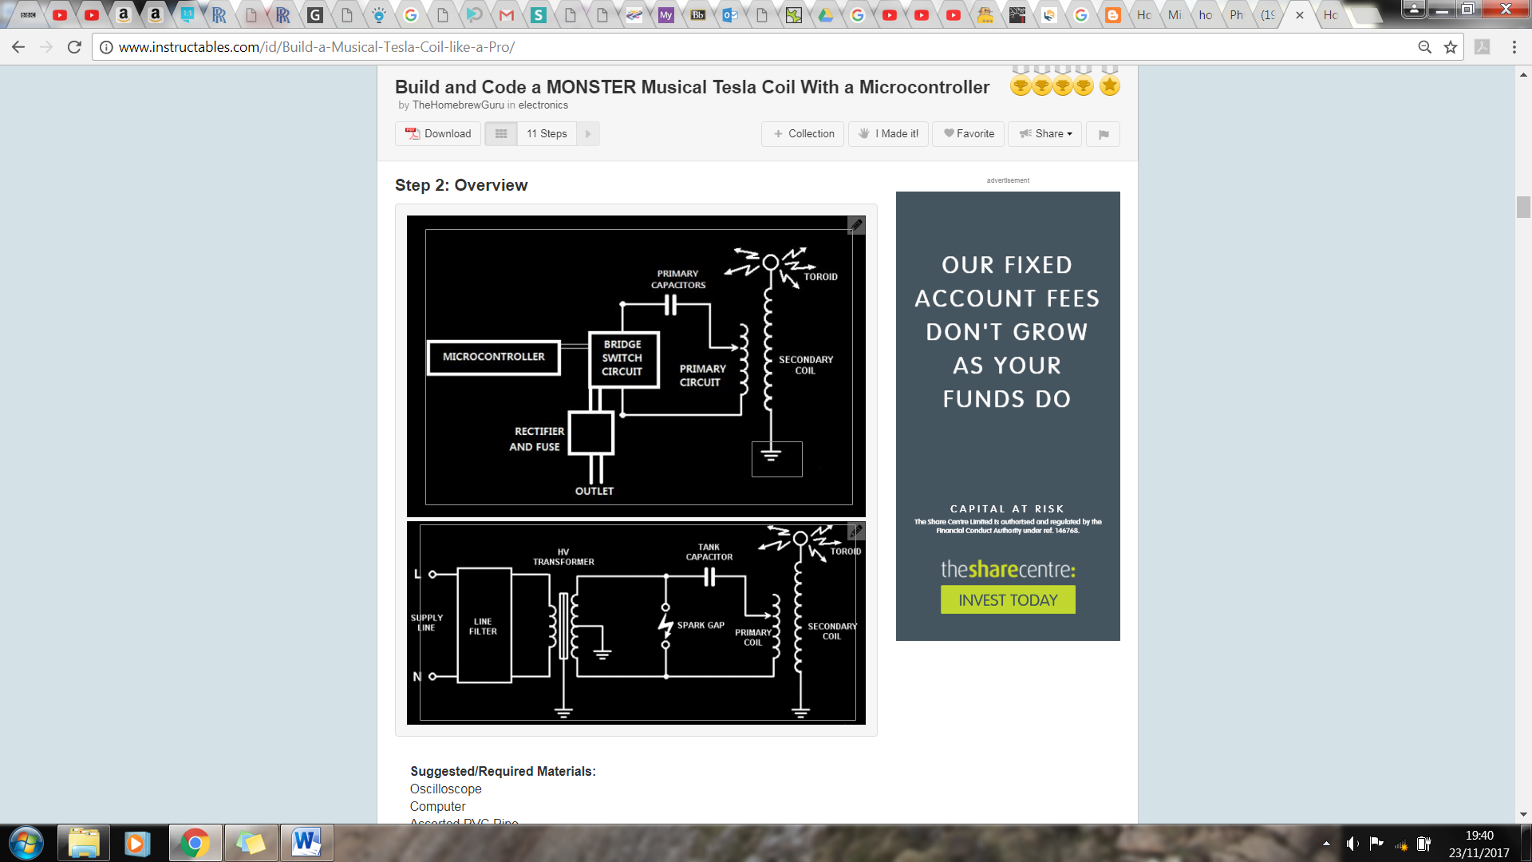

Figure : Spark gap tesla coil circuit(left) and a switching tesla coil circuit(right) [11]

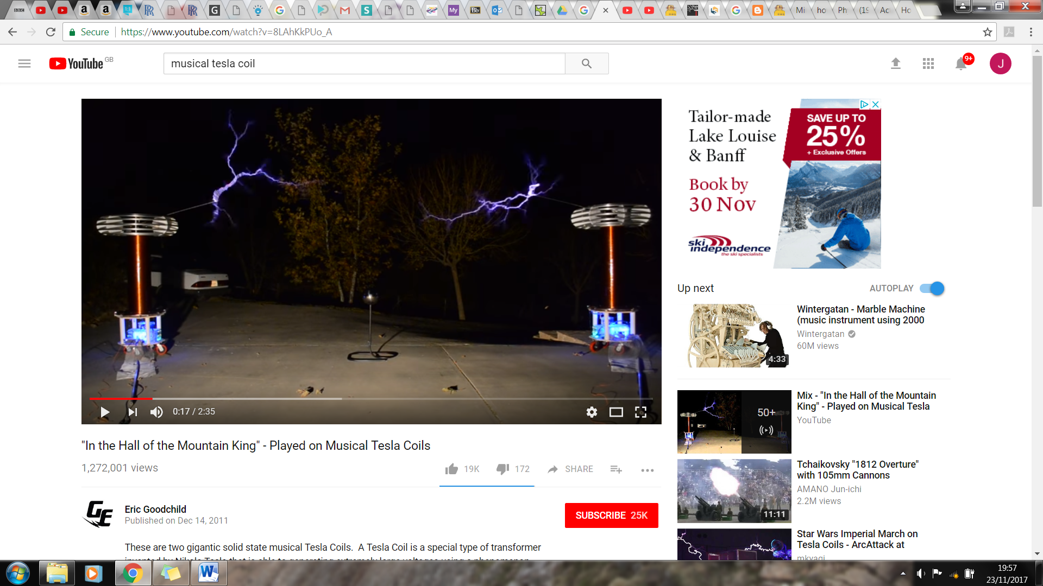

Figure : Streamers being created by tesla coil playing "In the Hall of the Mountain King" [12]

To make it play music the spark gap needs to be replaced by a switching circuit (right hand circuit in figureX) which connects and disconnects the capacitor from the primary coil (switching circuit diagram). To get it to play music the switching frequency is modulated by the music signal which induces a voltage in the secondary at a given frequency, producing streamers at a certain frequency which will causes the air to vibrate at that frequency and produce the correct sound [12].

# Bibliography

|  |  |
| --- | --- |
|  |  |
|  |  |
|  |  |
|  |  |
|  |  |
|  |  |
|  |  |
|  |  |
|  |  |
| [10] | Admin, "Breakdown voltage/Dielectric strength (Breakdown of Insulator)," The Physics Fact book, 15 September 2014. [Online]. Available: https://electronicspani.com/breakdown-voltagedielectric-strength/. [Accessed 23 November 2017]. |
| [11] | TheHomebrewGuru, "Build and Code a Musical Tesla Coil With a Microcontroller," instructables, [Online]. Available: http://www.instructables.com/id/Build-a-Musical-Tesla-Coil-like-a-Pro/. [Accessed 23 November 2017]. |
| [12] | E. Goodchild, ""In the Hall of the Mountain King" - Played on Musical Tesla Coils," Youtube, [Online]. Available: https://www.youtube.com/watch?v=8LAhKkPUo_A. [Accessed 23 November 2017]. |
| [13] | "The musical tesla coils," physics central- phisics buzz blog, [Online]. Available: http://physicsbuzz.physicscentral.com/2007/11/musical-tesla-coils.html. [Accessed 23 November 2017]. |